Test Case: tc001_SPX_Dev5_Crear_Solicitud_Articulo_Almacen
Step 1 - Enter username and password and click to button Enter : Credentials Entered
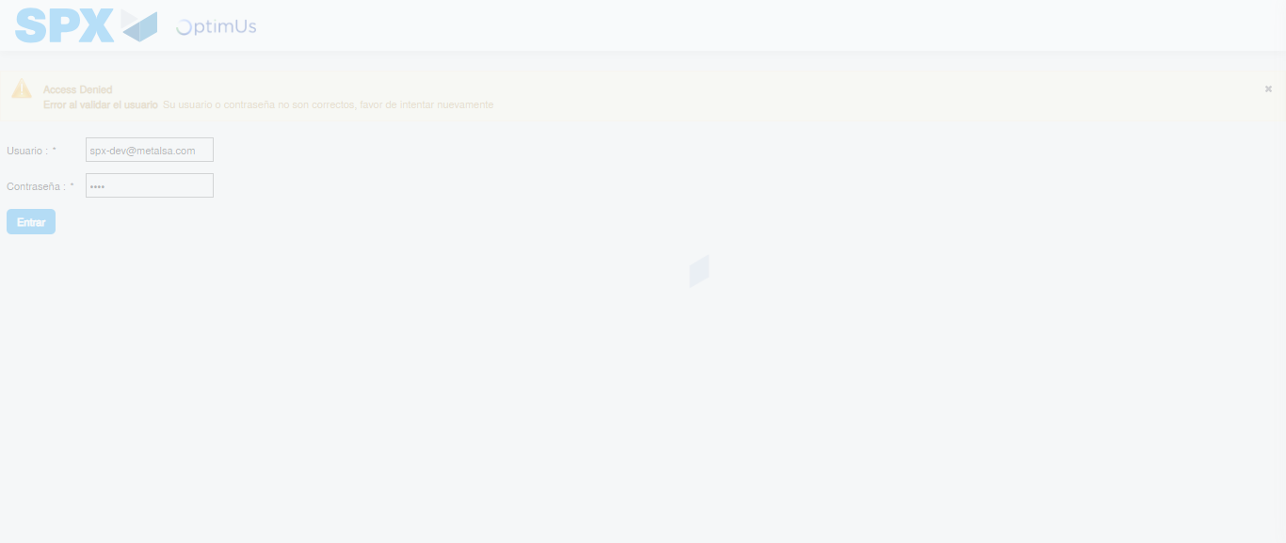Image file-name: QC_Testing-tc001_SPX_Dev5_Crear_Solicitud_Articulo_Almacen-1787941197499

Step 2 - Select to UEN and Access to Request for a New Inventory Item : UEN Correctly selected and Correct access
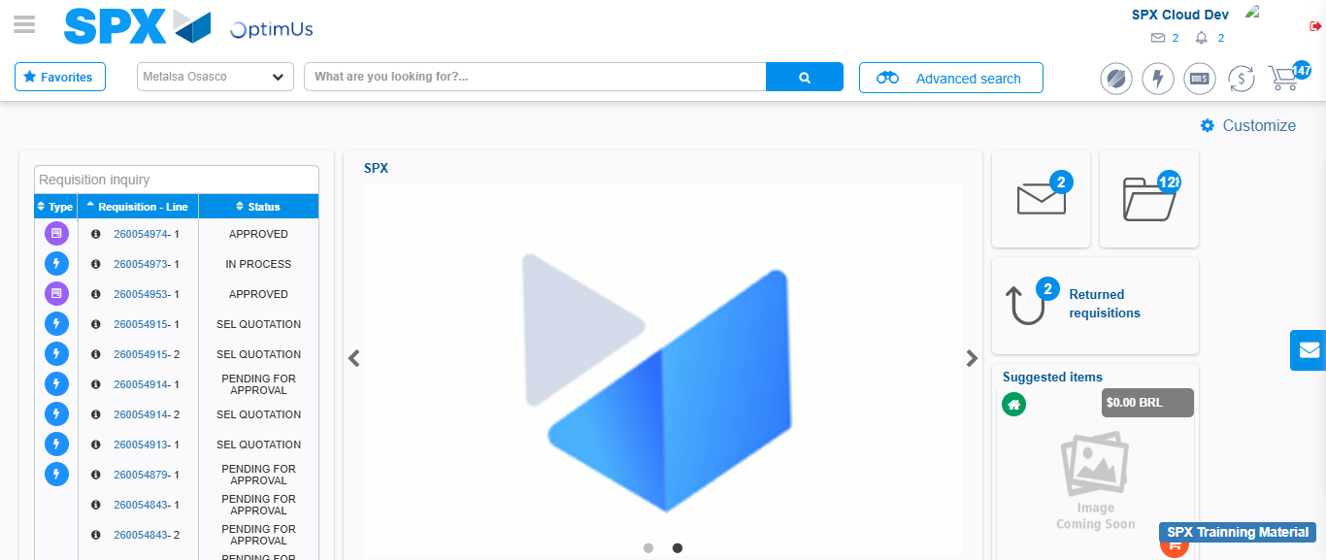Image file-name: QC_Testing-tc001_SPX_Dev5_Crear_Solicitud_Articulo_Almacen-1787941276915

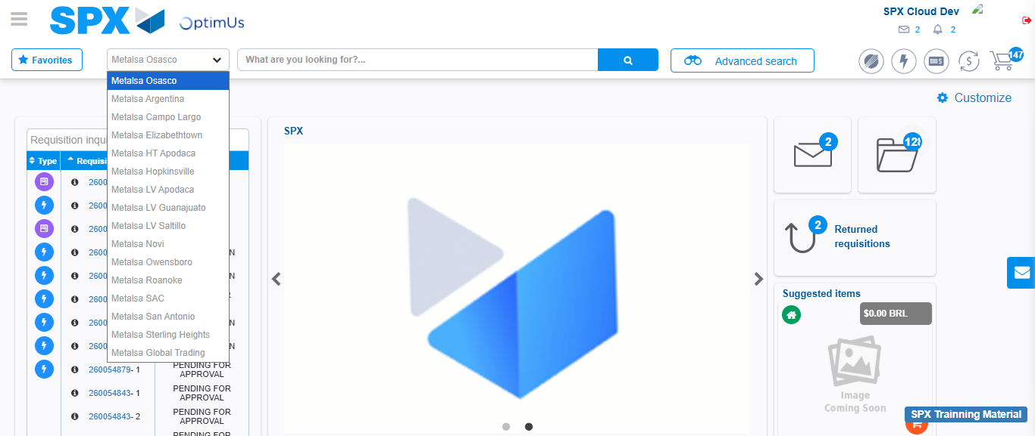Image file-name: QC_Testing-tc001_SPX_Dev5_Crear_Solicitud_Articulo_Almacen-1787941277781

Image file-name: QC_Testing-tc001_SPX_Dev5_Crear_Solicitud_Articulo_Almacen-1787941287379

Step 3 - Select options first section : Options seleted correctly
Image file-name: QC_Testing-tc001_SPX_Dev5_Crear_Solicitud_Articulo_Almacen-1787941287787

Image file-name: QC_Testing-tc001_SPX_Dev5_Crear_Solicitud_Articulo_Almacen-1787941288054

Step 4 - Select options at Screen: Options seleted correctly
Image file-name: QC_Testing-tc001_SPX_Dev5_Crear_Solicitud_Articulo_Almacen-1787941287787

Image file-name: QC_Testing-tc001_SPX_Dev5_Crear_Solicitud_Articulo_Almacen-1787941288054

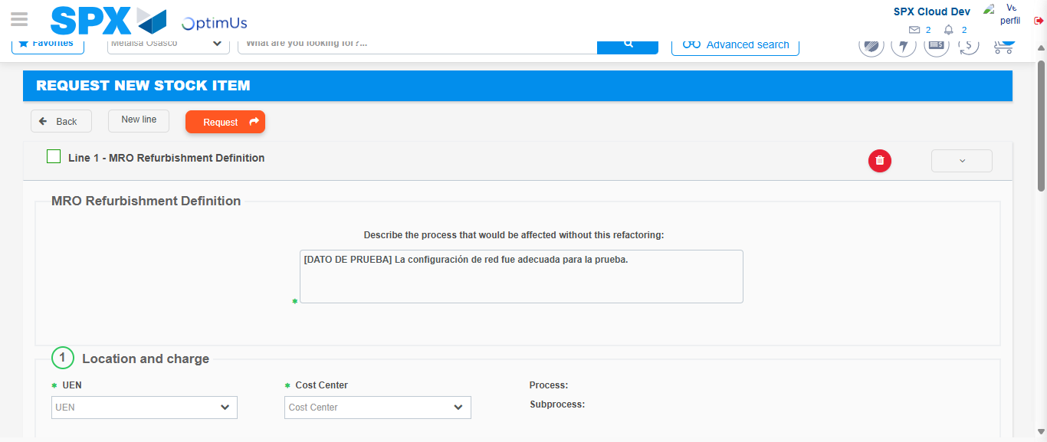Image file-name: QC_Testing-tc001_SPX_Dev5_Crear_Solicitud_Articulo_Almacen-1787941302560

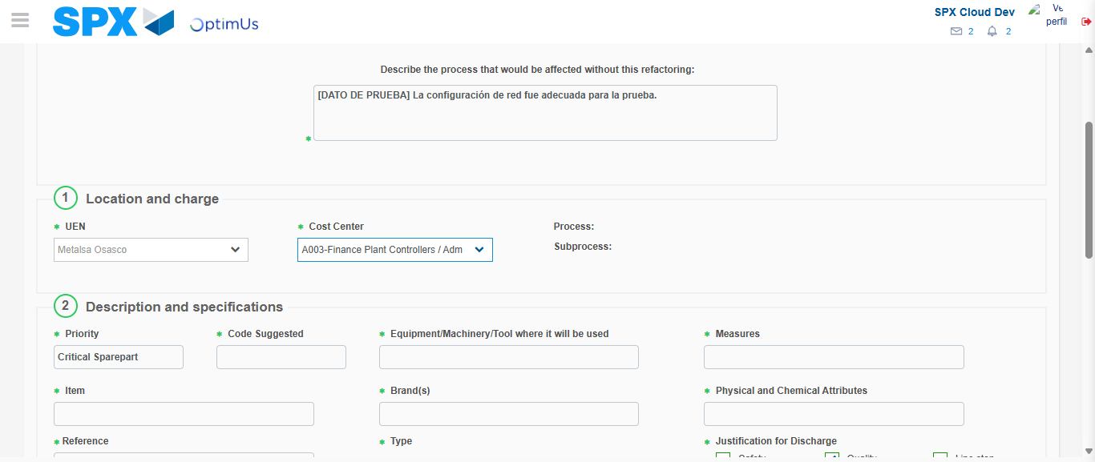Image file-name: QC_Testing-tc001_SPX_Dev5_Crear_Solicitud_Articulo_Almacen-1787941305945

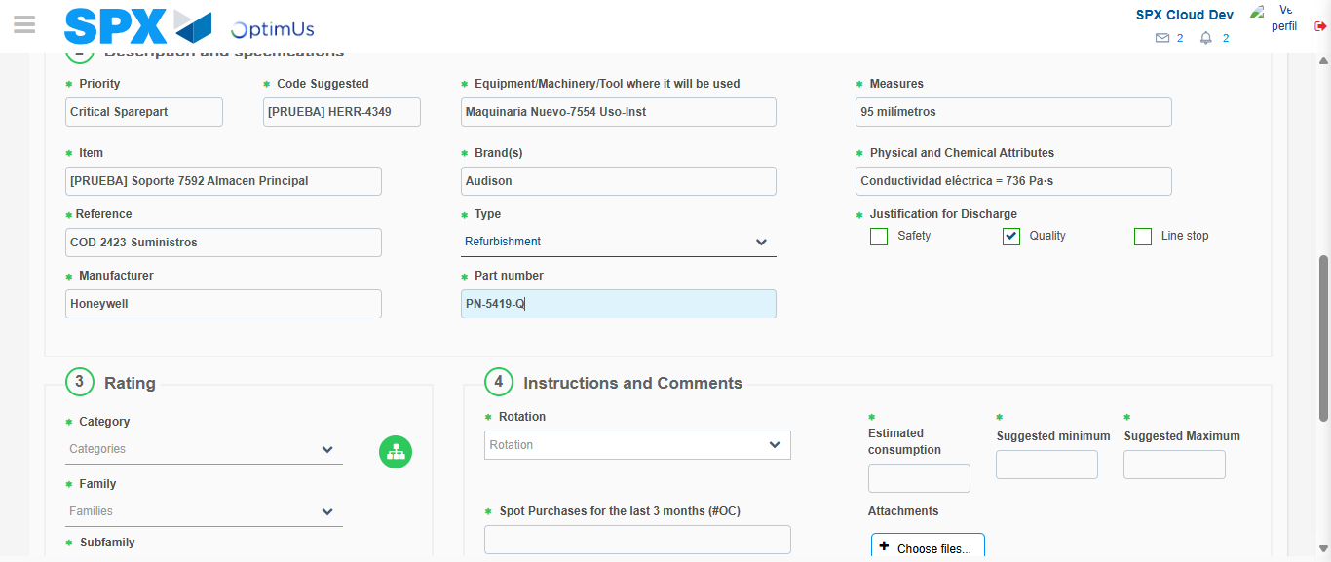Image file-name: QC_Testing-tc001_SPX_Dev5_Crear_Solicitud_Articulo_Almacen-1787941308646

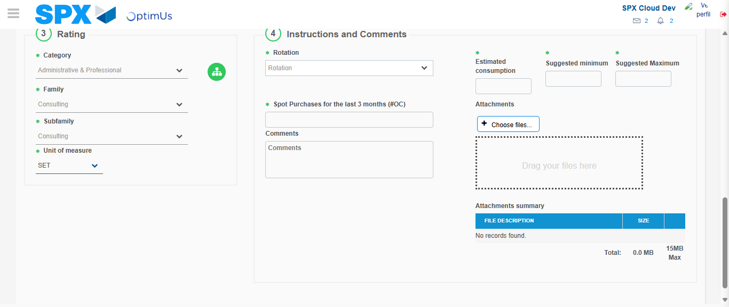Image file-name: QC_Testing-tc001_SPX_Dev5_Crear_Solicitud_Articulo_Almacen-1787941314760

Step 5 - Request New Item : Request Accepted
Image file-name: QC_Testing-tc001_SPX_Dev5_Crear_Solicitud_Articulo_Almacen-1787941276915

Image file-name: QC_Testing-tc001_SPX_Dev5_Crear_Solicitud_Articulo_Almacen-1787941277781

Image file-name: QC_Testing-tc001_SPX_Dev5_Crear_Solicitud_Articulo_Almacen-1787941287379

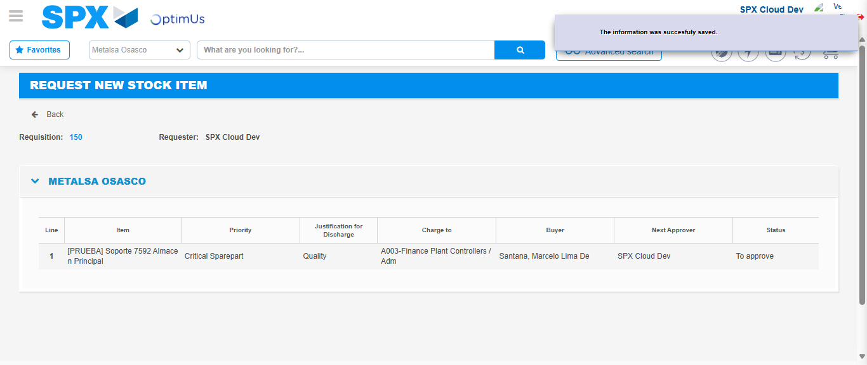Image file-name: QC_Testing-tc001_SPX_Dev5_Crear_Solicitud_Articulo_Almacen-1787941323186

Image file-name: QC_Testing-tc001_SPX_Dev5_Crear_Solicitud_Articulo_Almacen-1787941323422

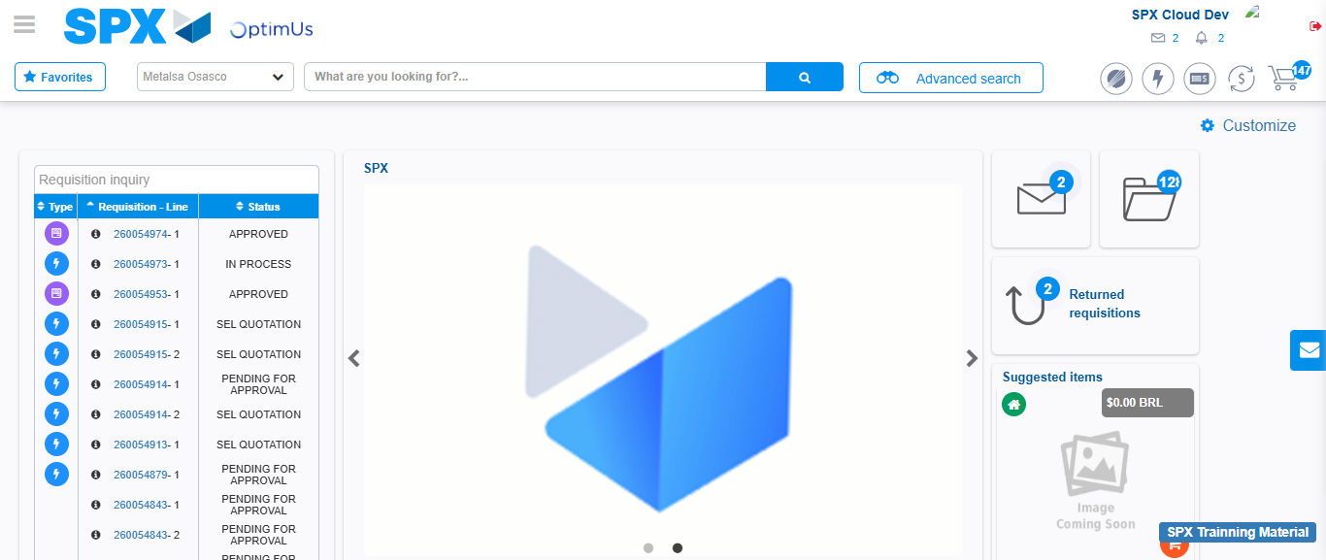Image file-name: QC_Testing-tc001_SPX_Dev5_Crear_Solicitud_Articulo_Almacen-1787941344925

Step 7 - Return to Main Page SPX : Return to Main Page SPX
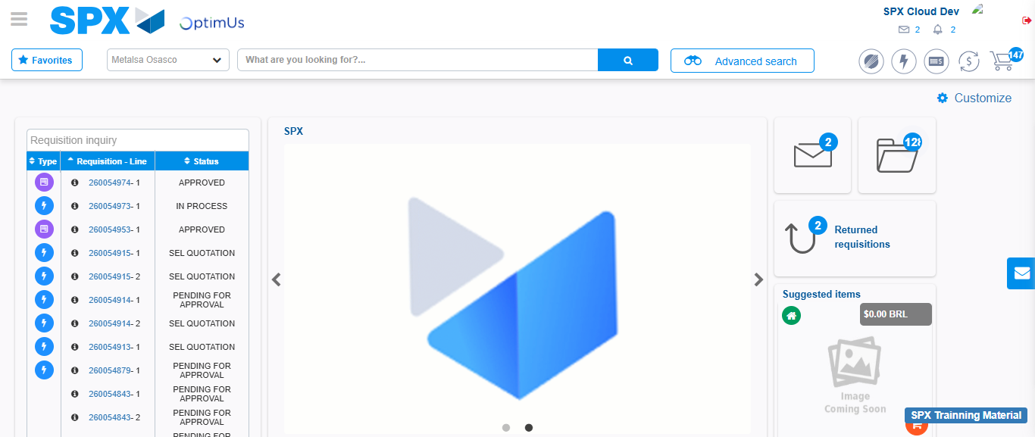Image file-name: QC_Testing-tc001_SPX_Dev5_Crear_Solicitud_Articulo_Almacen-1787941345393

